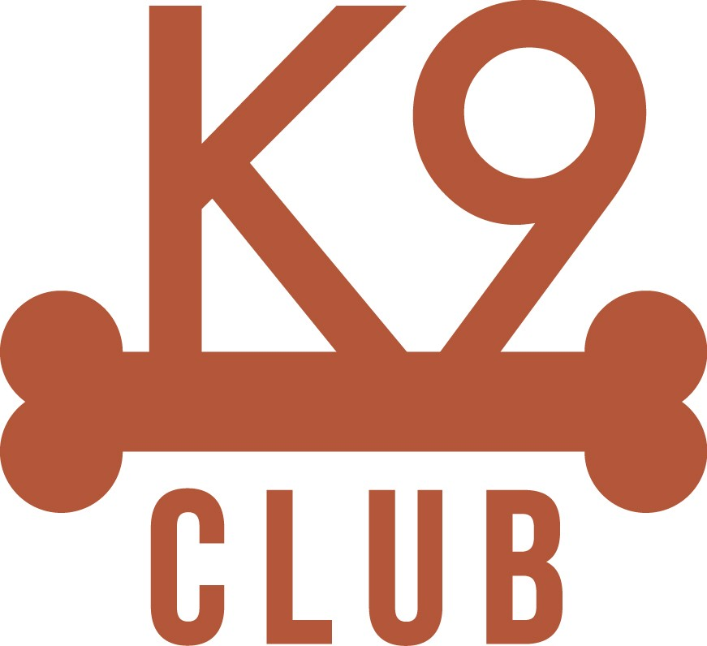

Standard Obedience Cues

The use of standard cue words is a basic tool used to get desired behavior from a dog. It is important to begin the cue with the pet’s name, otherwise how will the know you are speaking to. Following are the standard cue words used at our pet care center:
- “dog name” Come - dog stops what they are doing and comes to you
- “dog name” Off – dog needs 4 feet on ground
- “dog name” Leave it – dog needs get away from item or dog (litter, poop, urine, etc)
- “dog name” Wait – dog is to stop moving forward
- “dog name” Okay – release word for dog to proceed from a wait cue

Ensure the dog is focused on you and give them time to respond before you give a cue a second time. Praise the dog when they respond to your cue. Remain patient and be consistent.

Keeping Cues Strong
- In order to avoid teaching the dog to ignore us it is most successful to use each cue word only one time.
- Use verbal praise and brief pats to reward dogs for proper responses to cues.
- Reward proper responses
  - Praise, Praise, Praise!
  - Verbal or physical pats
  - Use treats (confirm no allergies) if working with a single dog

